Prospective New Member  HOA Community Solutions  Gig Harbor, Washington | 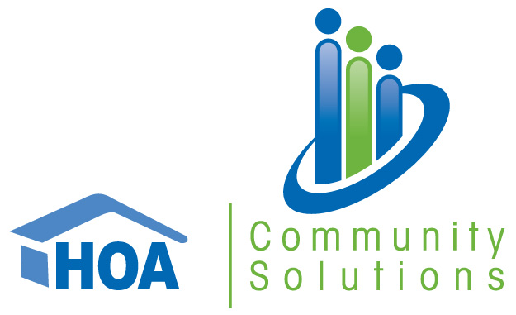
Last Updated: Aug 10, 2025 by Jacob Teich

Deal Overview
tl;dr
- Thesis: Acquire a growing management company in the Seattle metro area with strong customer & employee retention
- Key stats (TTM Apr’25):
  - $3.6M TTM Revenue and $1.1M PF Adj. EBITDA (30% margin)
  - 189 CAs, 21.6K doors, 36 FTEs (with 12 additional on-site employees)
    - 70% HOA / 30% Condo
  - 7-yr retention: 98% CA, 99% door, 88% employee
  - 32% CAM cut, 81% FTE cut
  - Revenue Mix: 69% Mgmt fee, 11% Transfer fees, 11% BSI, 5% addendum income, 3% collection fees
- Opportunities / Growth:
  - Improve bank service income with Alliance from 40% of FFR to 80% (estimated +$315K EBITDA in 2026)
  - Leverage TCC’s sales and marketing function to accelerate growth (only referrals and charity donations today)
  - Introduce maintenance services to a base of ~50 condos and 2.2K units
  - Increase addendum pricing
- Considerations / Risks:
  - Founder transition from Juanita who has run the company for 17 years
    - Juanita has identified a few potential MCP candidates and will help train the person she ultimately decides is the best fit for the role
- Software and Banking:
  - Client Accounting: Vantaca (transition from VMS in H2‘24)
    - Transition is fully complete
  - Corporate Accounting: Vantaca
  - Transfer & Resales: HomeWise
  - Payroll: QuickBooks
  - Client Banking: Alliance
- Transition Plan:
  - Roles
    - Juanita Carbaugh is the current owner / president who is looking to sell her business and transition out over a ~2-year period
    - Her husband is 20-years older than her, and she wants to spend more time with him
  - Who is there now that won’t be there post-close?
    - Juanita is transitioning out and but believes that there are a few people within the company that could step into the MCP role
- Other relevant info:
  - HOA Community Solutions Data Room
  - HOA Community Solutions Info Sheet
  - HOA Community Solutions Diligence Session Notes
  - HOA Community Solutions Model
- Deal Terms:
  - Revised Deal Structure
    - $6.8M EV @ Closing (6.1x PF Apr’25 Adj. EBITDA)
      - $5.6M Cash at closing
      - $1.2M Seller Note
      - 2026 revenue (excluding BSI) earnout paying $1.5M to $2.5M based on CAGRs of 15% - 25% (5.0x effective multiple)
  - $5.8M EV @ Closing (7.0x Underwriting EBITDA)
    - $4.6M Cash at Closing
    - $1.2M Seller Note
    - 2026 earnout paying 8.0x any incremental EBITDA above $999K (10% hurdle)

Transaction overview
HOA Community Solutions, based in Gig Harbor, WA (Seattle metro area, near Tacoma) is an association management company with 36 employees serving 189 CAs and 22K units. The portfolio is approximately 70% HOAs and 30% condo associations. The Company is 100% owned by Juanita Carbaugh who founded the Company in 2008. Juanita is looking to sell the Company and transition to retirement over the next two years, the purchase agreement will include a 1-year employment agreement. TCC has developed a relationship with Juanita through multiple conversations over the last year including in-person meetings at conferences.

Valuation & Earn-Out Structure
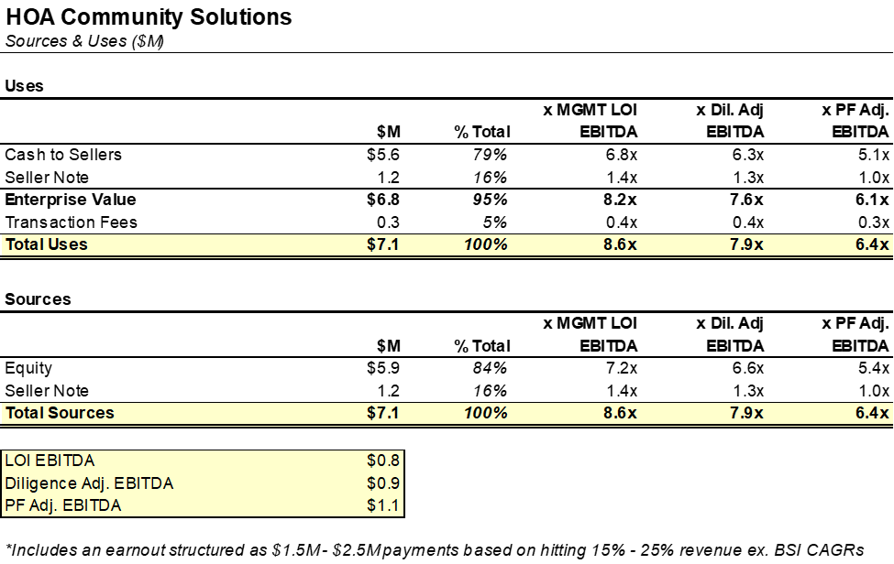

Commentary

Our original LOI underwriting EBITDA implied a 8.2x multiple, while our Dil adj. EBITDA implies a 7.6x EBITDA multiple. When factoring in the improved Alliance BSI agreement (40% to 80% of FFR) and normalized rates (2.75%), our implied multiple declines to 6.1x.

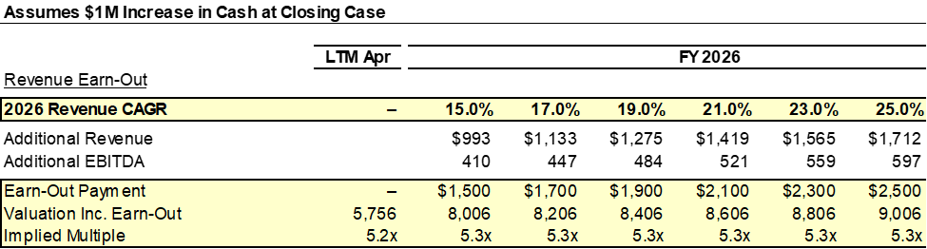

Valuation: $6.8M EV (6.1x PF Apr’25 Adj. EBITDA); $5.6M at close with a $1.2M seller note.

Seller Note: 2-year term with a 6.5% cash interest rate, interest and principal paid quarterly.

Earnout: A FY2026 revenue (excluding BSI) earnout paying $1.5M to $2.5M based on a 15% - 25% revenue CAGR hurdle.

Employment Agreements: Juanita will sign a one year employment agreement at a $200K salary with the opportunity to extend.

QoE vs. LOI EBITDA Bridge
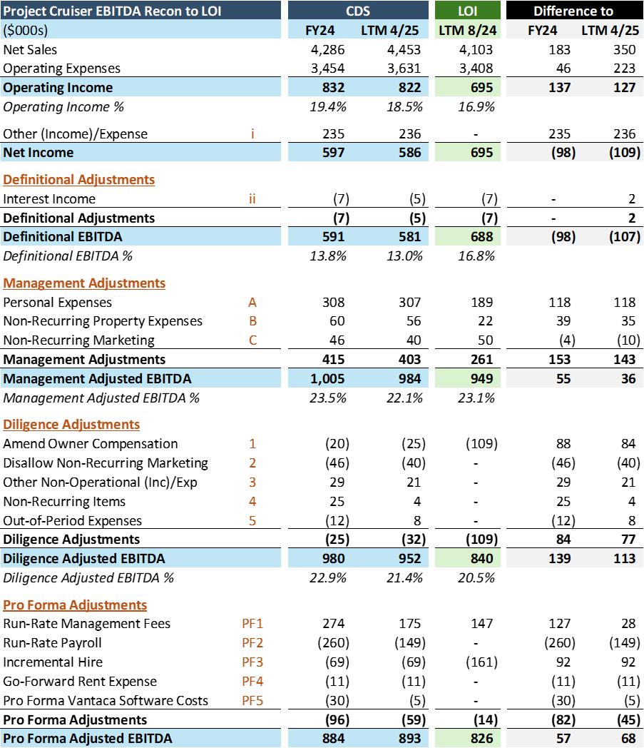

Commentary

Our QoE Diligence Adj. EBITDA is 8% higher than we initially underwrote at LOI, primarily due to additional personal expenses identified during diligence. Our run-rate adjustments include annualizing net customer wins and personnel hires. We’ve also burdened the QoE EBITDA with an additional manager to help support the existing portfolio & take on new clients.

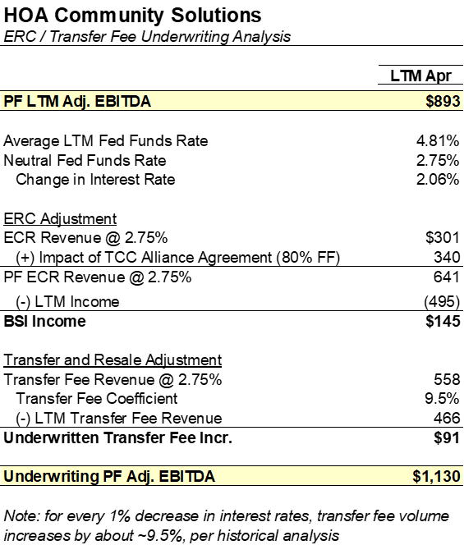
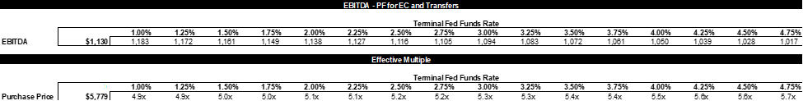

Commentary:

We have created a projection model using historical macroeconomic data to estimate the impact of future rate cuts. We found that for every 1% decrease in interest rates, transfer fee volume increases by ~9.5%. For HOACS, assuming the Fed Funds Rate decreases to 2.75%, ECR will decline by $194K and Transfer Fees will increase by $91. This brings UW PF Adj. EBITDA down to ~$1.1M.

Underwriting Model and MTB Plan
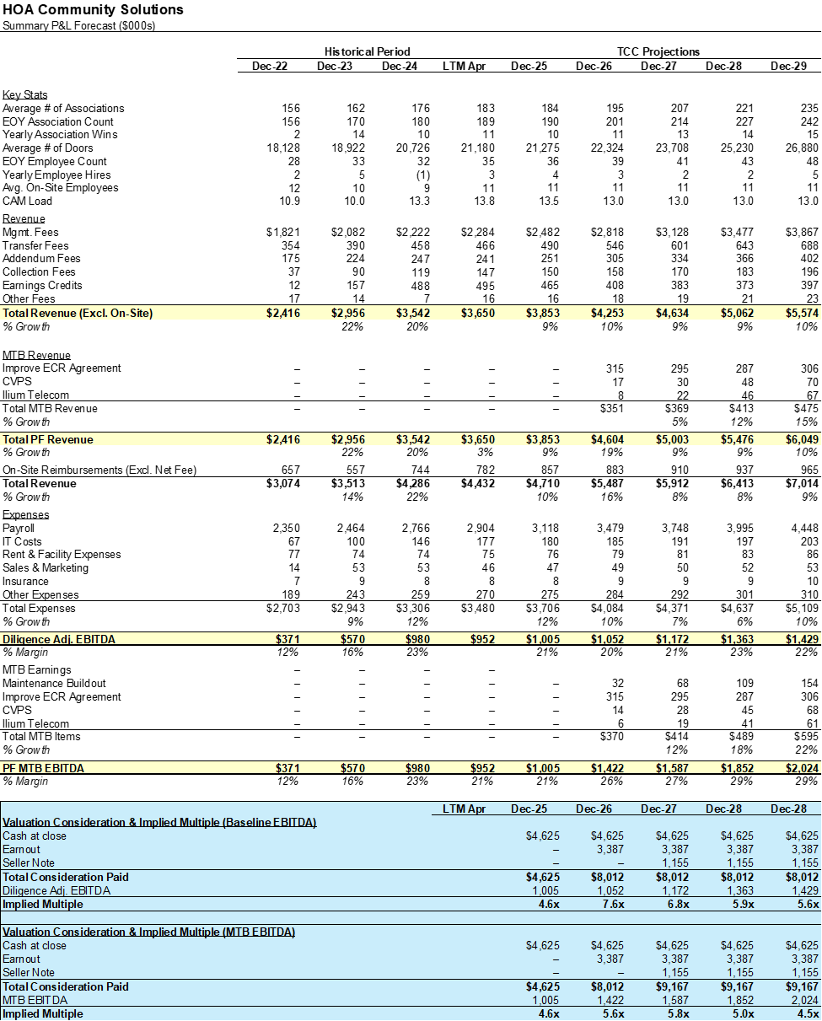

Commentary

HOACS’ strong customer retention and client demand gives it a clear path to growing to ~$2M of EBITDA, enabled by a deep management team, extensive backlog, and a large addressable market in the Seattle metro, even when accounting for declining interest rates.

The most addressable MTB lever is updating the AAB earnings credit agreement to match TCC’s new structure (80% of FF). The company currently operates with an agreement that is 40% of FFR, meaning we would capture an additional $315K of EBITDA immediately after implementing

Implementing CVPS cash back payments represents a $68K revenue opportunity at a 50% penetration rate, which assumes bill pay volume at similar levels to W360 and partial time allocation from a W360 offshore administrative employee.

Offering Ilum Telecom services would result in ~$61K of expected EBITDA, assuming a 40% penetration rate and average revenue per CA of ~$700, according to Tereno’s estimates.

Key Stats Comps Table
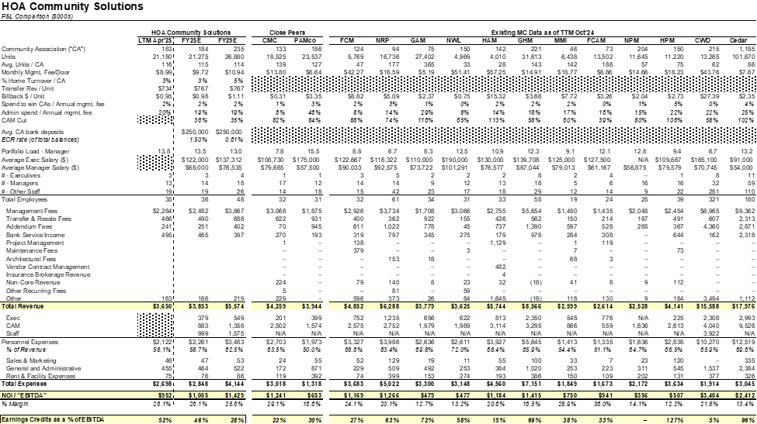

Commentary

HOACS’s profit margins are among the highest in our peer group, primarily due to the lower than average CAM cut and employee compensation as a % of revenue. There are team leads for managers and accountants, but her organization lacks a true executive layer under herself to manage department heads.

The two most similar MCs in terms of customer profile are CMC and PAMco, which have roughly ~150 customers on average and 21K units. Another key similarity is that all three companies have 50% - 66% personnel expenses as a % of revenue.

Summary Income Statement
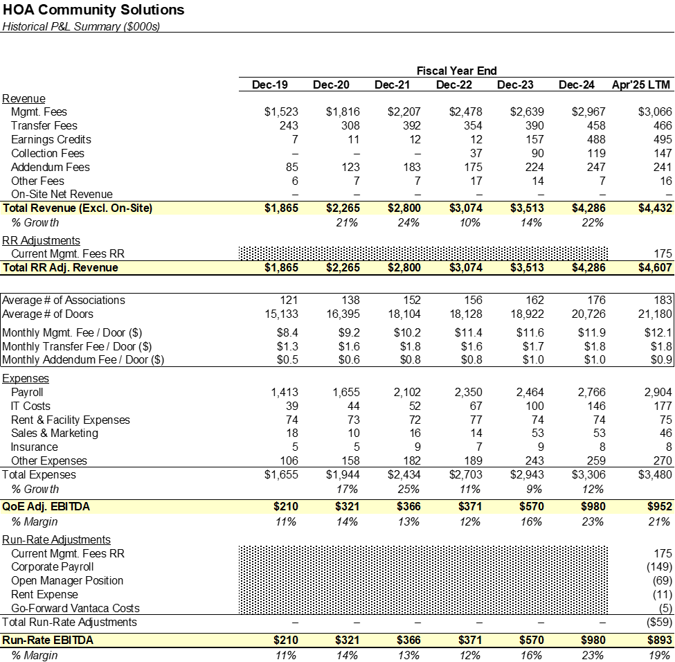
Commentary

HOA Community Solutions operates at ~19% RR EBITDA margins in the LTM period. The company’s largest expense is payroll, which has grown with scale but remained proportionate to revenue. The company has grown substantially, as revenue has more than doubled since 2019 while margins have expanded steadily. The company maintains a lean cost structure across IT, rent, and marketing. Recent EBITDA uplift is largely driven by increased bank service income.

Long-Term Revenue Performance: 2019 - LTM Apr'25
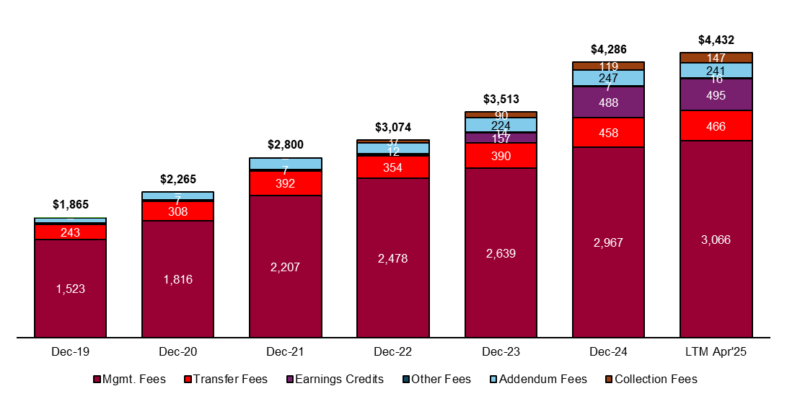

Revenue Breakdown (% of Total)
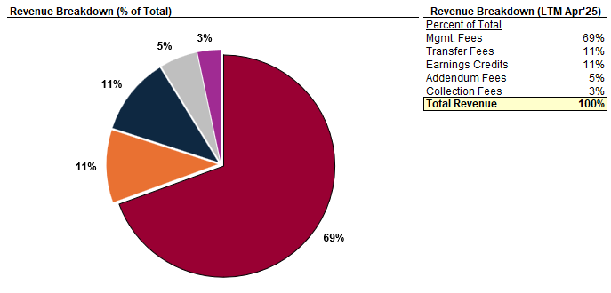

Customer Overview
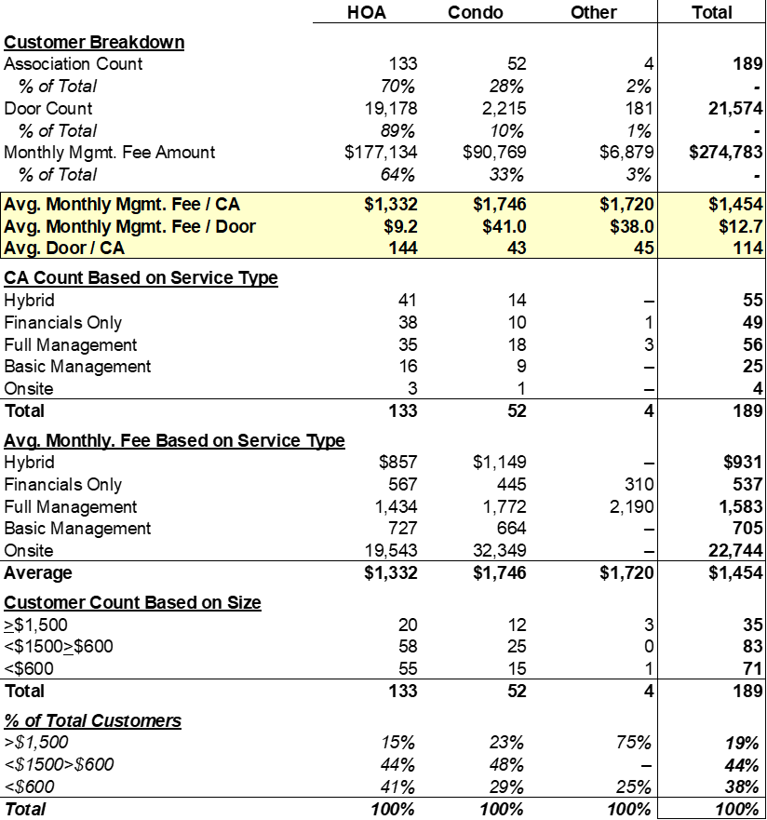

Commentary
HOACS oversees a diversified portfolio of 189 associations and ~22K units. HOAs represent 70% of the portfolio in terms of CA count and 90% of the portfolio in terms of units. Juanita’s ideal client profile is an HOA community with 100 or more homes. The company offers three main service types: full management, financial-only, and a hybrid offering that has some remote services (like board meetings and limited inspections).

Customer Retention
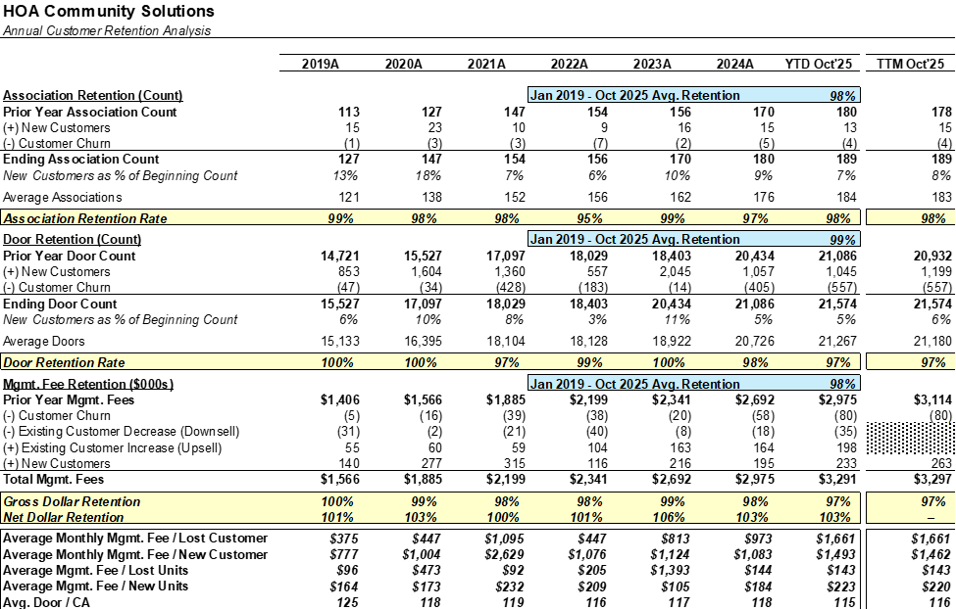

Commentary
HOA Community Solutions has maintained an average customer retention rate of 98% over the past seven years. Juanita credits this success to her high-touch, relationship-driven approach to client management, a factor that presents some risk as she begins to transition out of the business.In 2020, the company set a target of onboarding two new clients per month. However, the capacity faced capacity constraints in 2021, leading to a temporary pause in growth. Juanita plans to reinstate the two onboards per month pace in September following the addition of a new manager to the team, along with another hire in early 2026. The company currently maintains a waiting list for new clients through November. Recent portfolio growth has largely been fueled by clients transitioning from other management companies, accounting for roughly 70% of new business. The remaining growth primarily stems from communities that were previously self-managed. Juanita acknowledges that she frequently offers new contracts at lower rates than competitors, suggesting potential room for strategic pricing adjustments post-close.

Customer Wins & Losses
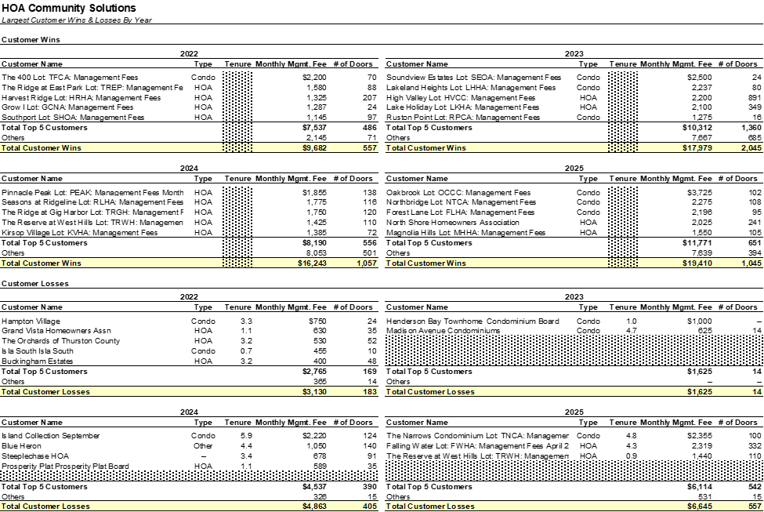

Commentary
Juanita attributes the few client losses experienced to an isolated issue with a former manager and to disengaging from particularly challenging clients that ultimately posed more liability than value to the business. Juanita’s team conducts due diligence on prospective clients, assessing their needs to better align pricing and service offerings. The strong backlog of new customers enables the company to be selective in choosing which clients to onboard, contributing to consistently low attrition rates. New client relationships are primarily generated through attorney and vendor referrals, as well as inbound leads from Google searches.

Top 20 Customer Overview
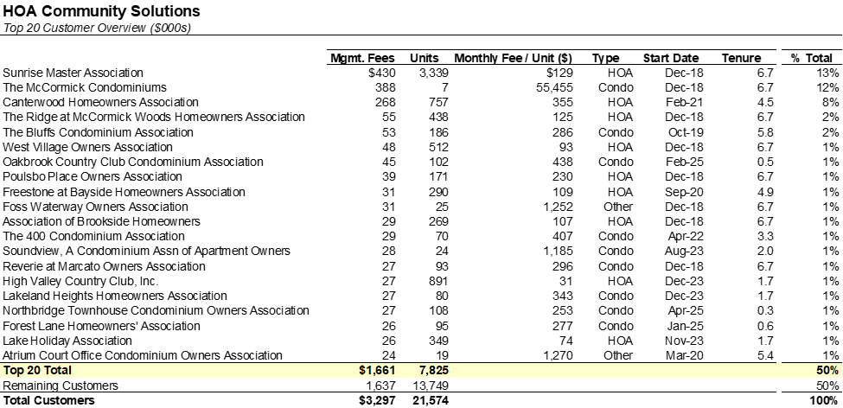

Commentary

The largest three associations, Sunrise Master, McCormick Condos, and Canterwood are all on-site associations with their on-site employee reimbursements included in overall management fees. Excluding the three on-site associations, no single customer accounts for more than 2% of revenue.The company’s largest customers have an average tenure of 4.3 years.

Annual Cohort Analysis
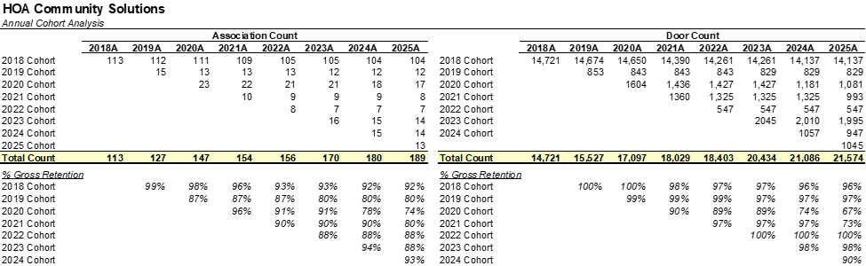

Employee Overview
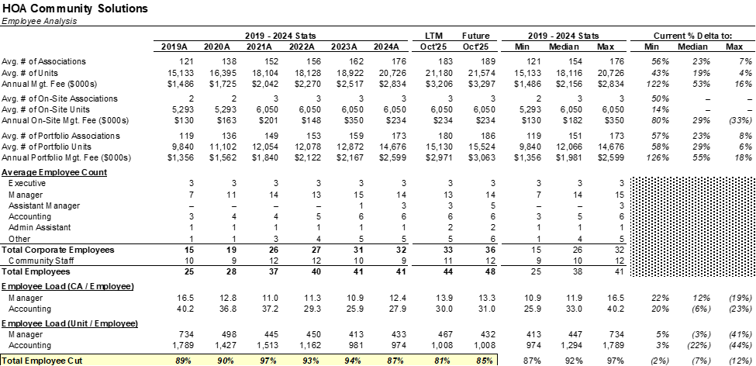

Commentary

HOA Community Solutions currently has 36 corporate employees: 3 executives, 14 managers, 5 assistant managers, 6 accountants, and 8 additional staff members. The company is operating under higher loads, with CAM loads of 13.3 compared to the historical average of 12.4. Juanita has indicated they are maxed out from a capacity standpoint and is actively looking to hire a manager, and we’re assuming hiring another manager in 2025. The company also has 12 on-site personnel.

Employee Retention Analysis
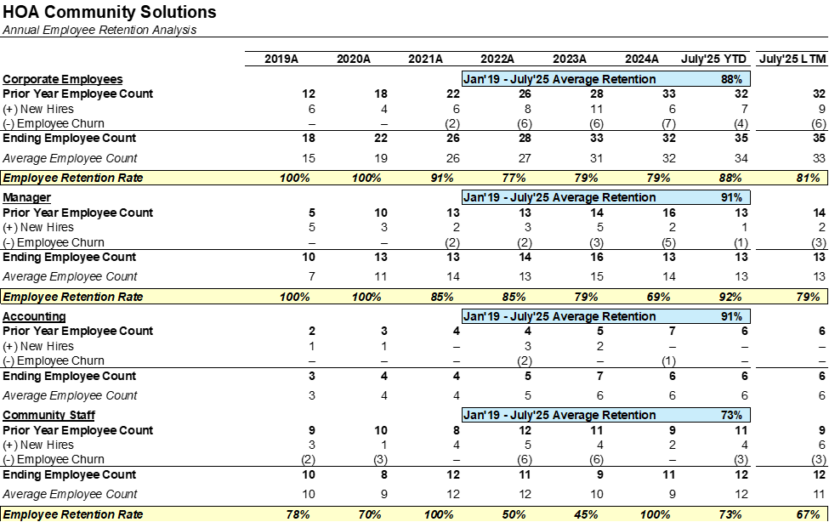

Commentary
HOACS has had an 88% average corporate employee retention rate going back to 2019. Juanita attributes this success to the management of her team, which highlights potential key man risk should she not find a suitable replacement. Most employee departures have occurred naturally due to retirement or relocation. In a few instances, turnover resulted from employees not being the right fit for their roles, with one case of a manager leaving to join another management company.

Manager Portfolio Analysis
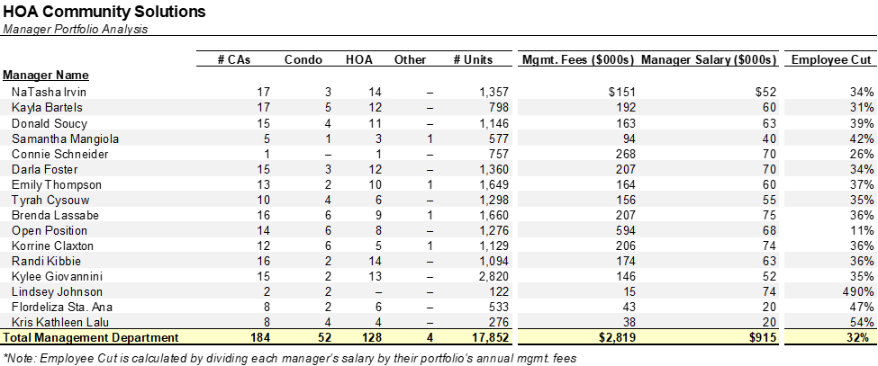

Commentary

HOA Community Solutions has a CAM cut of 32%, which is below our industry average (40% - 45%).The company splits their managers into three groups, each with a team lead and an offshore assistant who addresses homeowner issues and administrative items.

Org Chart
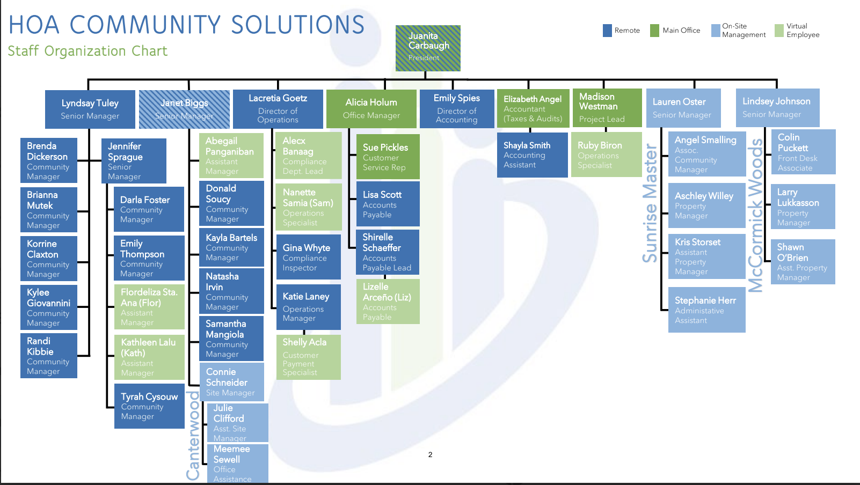

Commentary

The leadership team is anchored by Juanita Carbaugh, who remains involved across various parts of the business. She directly oversees the leadership team, manages customer escalations, and works with Madison Westman on business development initiatives. Corporate accounting also sits under her leadership. Supporting her is Lyndsay Tuley, a long-time employee of over 16 years who brings extensive manager experience. Lacretia Goetz, another key member with 15+ years, serves as QB across departments, managing billing, compliance, the Vantaca implementation, and customer service. She’s been named as one of the people who could succeed Juanita.

Alecx and Samantha rotate seasonally between compliance and billing, while Gina Whyte handles daily compliance inspections. Katie Laney oversees IT and is responsible for all Vantaca-related matters. Shelly provides customer payment support, and Alicia Holum, the office manager, currently handles AP (transitioning to Emily) but is not expected to take on increased responsibilities long term. Emily Spies, the new Director of Accounting, was hired in March 2025, and will be overseeing AP, corporate accounting, and payroll. Although not on the senior team, Madison Westman is Juanita’s right hand person and is being considered for future leadership.

In terms of succession planning, Lauren Oster, daughter of senior leader Janet Biggs (who plans to retire within five years), has strong leadership potential and may take on the role of Director or VP of Field Services to maintain client relationships. Jennifer Sprague is another promising candidate for that role, though personal circumstances present some uncertainty. While internal promotion remains a priority, Juanita acknowledges that external recruitment may be required for the future president role.

